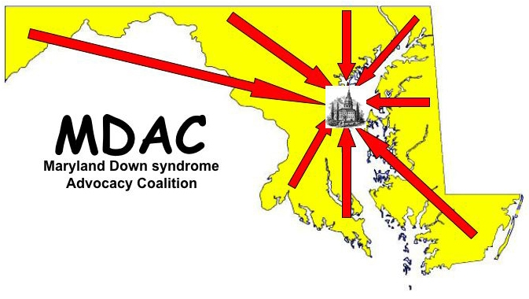
SUPPORT SB 654 – An Act Concerning Health – Down Syndrome – Required Information
(Down Syndrome
Pro-Information Bill)

The Maryland Down syndrome Advocacy Coalition (MDAC), a statewide advocacy coalition composed of representatives from Down syndrome groups and other disability organizations throughout the State of Maryland, urges you to support SB 654, a bill requiring the Department of Health and Mental Hygiene to provide accurate, up-to-date information about Down syndrome to health care facilities to distribute to patients who receive a prenatal or postnatal diagnosis of Down syndrome.

BACKGROUND
- Down syndrome is the most common chromosomal condition, affecting one out of every 691 babies born in the United States. It occurs when an individual has a full or partial extra copy of chromosome 21.
- Though people with Down syndrome experience cognitive delays ranging from mild to moderate, many of them attend school, work, possess many talents, and contribute to society in meaningful ways.
- While people with Down syndrome may have an increased risk for certain medical conditions, advances in medicine have made many of these conditions treatable and increased the life expectancy of people with Down syndrome from 25 in 1983 to 60 today.
- When patients receive a prenatal or postnatal diagnosis of Down syndrome, the informational materials they receive about Down syndrome are currently determined by the individual health provider.
- These materials may be accurate and up-to-date, but more commonly they are outdated, not reviewed by medical experts or endorsed by national Down syndrome organizations. At worst, they can be archaic and offensive, using terms such as “retarded” and “mongoloid.”
- The lack of consistency or quality-control in the information distributed by local health care providers creates unnecessary stress for many of our families while conveying an inaccurate picture of people with Down syndrome in society today.
- Other states such as Massachusetts as well as the federal government have passed laws requiring Departments of Health to distribute accurate, up-to-date information about Down syndrome that has been developed by national Down syndrome organizations in consultation with medical experts.
- There is currently no such law in Maryland, despite an important need for one.

SUPPORT SB 654, WHICH WOULD:
- Require the Department of Health and Mental Hygiene to make available certain information about Down syndrome that is accurate and up-to-date.
- Provide contact information for local services and groups to ensure that families touched by Down syndrome have access to the supports that every family in their position needs.
- Ensure that all Maryland families who receive the diagnosis of Down syndrome - regardless of where they live, deliver their baby, and without regard to race, ethnicity and culture - receive the same accurate, up-to-date, high-quality and consistent information that has been reviewed by medical experts and national Down syndrome organizations.

The Maryland Down syndrome Advocacy Coalition ** The Down Syndrome Network of Montgomery County ** The Down Syndrome Connection of Anne Arundel County**The Chesapeake Parent Down Syndrome Group**The Family Resource, Information & Education Network for Down Syndrome, Frederick County (FRIENDS)**Parents of Children with Down Syndrome (PODS) of Prince George’s County**Down Syndrome Association of Southern Maryland

